The Board of the Eastern Chapter of WEDA invites you to submit an abstract for a technical presentation at our Fall 2024 conference. The meeting be will held at the Maritime Conference Center outside of Baltimore, MD, from October 15-17, 2024. Book your room and register for the event to ensure your space as soon as possible!
Call for Abstracts:
This year’s meeting will be focused on Challengers in the Dredging Industry - Recruitment, Hiring, Education & Training, and Retainage.
Please limit your abstract to one page. Presentations on all aspects of dredging and disposal, navigation structures, environmental restoration, and related topics are welcome, and presentations specifically relevant to East Coast issues or projects are encouraged. If your abstract is accepted, you will be invited to present on that subject at the conference. You will not be asked to write and submit a technical paper. Speakers are required to register and pay fees accordingly.
Abstract Due Date: Abstracts are due no later than Friday, July 19, 2024.
Send abstracts to: Jason Raimondi, Program Manager WEDA Eastern Chapter, at jraimondi@geosyntec.com
When:  Tuesday, October 15th at 8 AM  -to-  Thursday, October 17th at noon  Add meeting to calendar    Where:  Maritime Conference Center (MITAGS)  692 Maritime Blvd.  Linthicum Heights, MD 21090  Make Reservations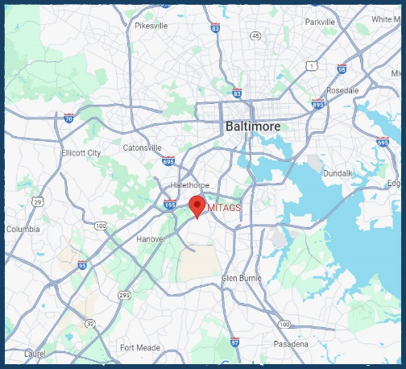 | Tentative Agenda: We are putting together the tentative agenda for the meeting. Once it is available, it will be posted here.  Location: View MITAGS layout  Maritime Institute of Technology and Graduate Studies Campus has over 100,000 square feet of meeting space, over 200 well-maintained guestrooms, a Chesapeake dining facility, a fitness center, a pool, a game room, a deck club lounge, specialty maritime training facilities, a Merchant Marine History throughout the campus—only 5 minutes from BWI airport, BWI Amtrak & Marc trains.  Conference Registration: The registration fee structure is as follows:  WEDA Member: $400  Non-member: $500  Gov't Employee: $400  Courses: $150 each  - Dredging 101  - Innovations Toward Achieving More Sustainable Management for Dredged Material  Students: $200 for qualifying students  
Sponsorships:
Premiere Sponsor - $2,000 (Exclusive Offsite Event + Gold)
- Features the event's sponsorship at the Guinness Open Gate Brewery and includes special recognition, signage, the ability to have a booth or table, and marketing items.
- Interactive logo on WEDA Eastern Chapter website, advertising in Conference agenda (Full Page ad, RGB PDF 300 dpi), Company Logo on Conference PowerPoint rotation
- Project Pictures or video on PowerPoint
- Recognition at the event
- Signage at the event
- Table for exhibition
Gold - $1,000
- Interactive logo on WEDA Eastern Chapter website, advertising in Conference agenda (1/2 page ad half page: vertical size 3.6" wide x 9.8" high horizontal: 7.5" wide x 4.75 high) RGB PDF 300 dpi), Company Logo on Conference PowerPoint rotation
- Project Pictures or video on PowerPoint
- Recognition at the event
- Signage at the event
- Table for exhibition
Silver - $500
- Interactive logo on WEDA Eastern Chapter website, advertising in Conference agenda (1/4 Page ad ONLY option 3.6" wide x 4.75) RGB PDF 300 dpi, Company Logo on Conference PowerPoint rotation
- Recognition at the event
- Signage at the event
- Table for exhibition
Click here to sponsor online. For payments by check, please get in touch with us at Info@WesternDredging.org.
Hotel Reservations:
- By phone (available 24 hours a day) to 1-410-859-5700 and be sure to ask for “WEDA Western Dredging Association” or Group Code WEDA 24
- By Internet— Click Here to Make Reservations
See you in Maryland!
Steve Miller
President, WEDA Eastern Chapter
Ellicott Dredges, LLC
smiller@dredge.com

